Module 2 Lesson 2
Business Proposal: Proposing a Solution
Criteria  Audience Engagement (AE)  Organisation (O)  Language Use (LU) | Learning Outcomes:  - Analyze the purposes and structure of a major section, as well as rhetorical strategies and linguistic devices for effective persuasion  - Apply brainstorming techniques to generate ideas for an innovative solution  - Identify different types of transitions (focus, thought, and logic)  - Evaluate and present effective rhetorical strategies and linguistic devices for persuasion
Lesson purpose
In this lesson, you will learn how to craft a compelling draft of “Section 4: Proposing a Solution”. You will analyze the structure and purposes of this section, brainstorm effectively to generate and organize ideas, and use persuasive language to highlight the benefits of your solution. During this lesson, you will also explore the use of transitions when trying to achieve coherence in your writing, to make your proposal logically structured and easy to follow.
M2L2: Pre-lesson activities
Writing Checkpoint 1 (Evidence-based Problem Justification) relates to "Section 3: Evaluation of Current Market and Industry Needs” of the Business Proposal. Before M2L2, answer the questions below and post your answers in the M2L2 Canvas Discussion titled M2L2: Preparation for Writing "Section 3: Evaluation of Current Market and Industry Needs”:
- What is your project group’s chosen business communication problem?
- For Section 3, what initial market and/or industry needs or problems have you identified? Outline these problems.
- What is your proposed solution? What makes this an innovative, feasible, and effective solution?
- Which sources are you going to use to support these market and/or industry needs and problems? Identify 3 sources and list them in APA style (7th edition).
E.g,. HSBC. (n.d.). Age-friendly banking and services for the elderly. https://www.hsbc.com.hk/community-banking/age-friendly/#:~:text=Banking%20with%20us%20simpler%20and%20faster&text=We%20also%20have%20Community%20Care,our%20Smart%20Seniors%20for%20assistance
Warm-up activity
Your business proposal should be persuasive throughout; however, this is particularly important for Section 4: Proposing a Solution. Why? In your opinion, what persuasive strategies will be effective and appropriate for your business proposal? Discuss with your partner(s).
Activity 1 | Purposes & organization of “Section 4: Proposing a Solution”
In Section 4, the focus shifts to presenting a well-thought-out and feasible solution that addresses the identified gaps in the market. This section is crucial for demonstrating how your proposed solution directly responds to the business communication problem and opportunities identified in your analysis. You need to learn to integrate the benefits and advantages of your innovation into various parts of the section. This approach ensures that the value of your innovation is clearly communicated and reinforced, making your proposal more persuasive and impactful.
Read the sample Section 4 below. Identify the purpose and details of each sub-section. Explore what each sub-section should include.
Please note that you should not use this sample as a model for how you would compose your own proposal as your project topic may be very different from the sample’s. Also, note that this is not a perfect sample, and improvements would need to be made in content and language.
Content | Purpose & details
4. Proposing a Solution
4.1 Transformative AR Education Solution (ARES)
We propose an innovative AR education program called ARES tailored for older, non-tech savvy investors in Hong Kong. This program demystifies emerging technologies, such as blockchain, cryptocurrency, and AI by presenting their investment potential in an accessible, engaging way. Delivered via a mobile truck that visits different neighborhoods, the program removes barriers related to transportation and mobility, ensuring direct access for our target users. The primary goal is to empower older investors with the knowledge and confidence to make informed decisions in a rapidly evolving financial landscape.
4.2 Filling the Investment Knowledge Gap
Senior investors often face significant challenges when learning about complex technologies. ARES addresses these gaps through several features:
- Engagement: AR technology offers an interactive and immersive experience (Bacca et al., 2014). Concepts can be brought to life through visual simulations, quizzes, and interactive scenarios, making learning intuitive and enjoyable.
- Accessibility: The AR interface includes large buttons, intuitive navigation, and customizable settings for font size and contrast, accommodating varying visual needs. The mobile truck format brings the program directly to communities, overcoming geographical barriers.
- Personalization: Content adapts to each user’s progress, interests, and investment goals, ensuring relevance and resonance.
4.3 Strategic Alignment with Financial Institutions
This AR program aligns with the strategic goals of financial institutions in Hong Kong:
- Expanding Market Reach: By targeting older, non-tech savvy investors, institutions can engage a traditionally underserved demographic and expand their customer base (Institute of Ageing, The Chinese University of Hong Kong, 2018).
- Enhancing Customer Engagement: Offering innovative, interactive education demonstrates a commitment to empowerment and financial literacy, building trust and loyalty.
- Promoting Investment in Emerging Technologies: Educating this demographic about emerging technologies can increase their investment activities, benefiting both investors and financial institutions.
4.4 Unmatched Competitive Edge
Our program stands out as Hong Kong’s first AR financial literacy initiative for seniors, transforming complex concepts into engaging visuals. Our team will collaborate with the Division of Integrated Systems and Design and the Centre for Aging Science at the Hong Kong University of Science and Technology (HKUST). This partnership ensures technological excellence and age-appropriate, user-friendly content. Content can be regularly updated with input from financial institutions, and the mobile format brings learning directly to seniors, fostering participation and inclusion.
By combining AR technology with a mobile format, our solution addresses the identified gaps which align with financial institutions’ business goals, providing a unique competitive advantage. We believe ARES will transform how seniors learn about and engage with emerging technologies.

(414 words)

Activity 2 | Analyzing Rhetorical Strategies and Linguistic Devices of “Section 4: Proposing a Solution”
In Section 4, you need to persuade stakeholders to support and adopt your proposed solution. To achieve this, it is essential to provide a compelling argument that outlines the value of the solution and demonstrates how the solution addresses the communication problem and aligns with the goals of stakeholders. Rather than providing a dry and boring description of your solution, you need to use vivid, persuasive language as well as engaging examples and descriptions to communicate the value of the solution effectively.
Here are some common rhetorical strategies and linguistics devices used to achieve persuasion:
Rhetorical strategies | Linguistic devices
- Use of logical reasoning or evidence  - Use of emotive language  - Appeal to credibility | - Inclusive language  - Emotive language  - Repetition  - Use of comparatives and superlatives

Now, review the sample Section 4 again. Analyze the rhetorical strategies and linguistic devices used in the sample by answering the following questions:
1. What examples of logical reasoning or evidence are used to make the argument(s) convincing?
2. How do statistics, expert opinions, or research strengthen the credibility of the argument?
3. What emotive language is used to connect with the audience to evoke feelings of trust, excitement, or optimism?
4. What words or phrases are used to show empathy and inclusivity to make the solution more appealing?
5. i) Which key ideas or phrases are repeated throughout the section? ii) How does repetition reinforce the main message and make it more memorable?
6. Are there any uses of comparatives or superlatives to emphasize the uniqueness or distinctiveness of the solution?

Activity 3 | Brainstorming and organizing your own “Section 4: Proposing a Solution”
In the previous lesson, you learnt that asking (and answering) specific questions about the content of each sub-section can help brainstorm and organize your thoughts. Based on the sample section in Activity 1, the following brainstorming questions should help you develop your own version of Section 4.

Possible Questions
Sub-section 4.1
- What is your innovation called? Name it in a few words
- What does it do? Explain it in 1 sentence
- What are the unique, crucial, or outstanding features of your innovation?
- What is the ultimate goal of your innovation?
Sub-section 4.2
- Refer to your draft of Section 3: Evaluation of Market and Industry Needs: what gaps have you identified in the market or industry?
- What are the major needs of the stakeholders?
- What shortcomings or gaps have you identified in the existing communication strategies, products, or services?
- How does your innovation tackle these gaps and meet the needs of the stakeholders?
- Do you have any evidence-based research to support information in this sub-section, and how will it be integrated?
Sub-section 4.3
- Who are the target clients, customers, or users of your innovation? In other words, who will you sell the innovation to if it becomes a reality?
- What business goals do they have?
- How could your innovation help them meet these goals?
- Do you have any evidence-based research to support information in this sub-section, and how will it be integrated?
Sub-section 4.4
- What are the most significant features of your innovation?
- How do these features make your innovation stand out from your competitors or existing communication strategies?
Summary
- What are the key points (especially the solution’s advantages)?
- What is the transformative potential of the solution?
Remember that even though the Business Proposal is an individual assessment, you can still work as a group for brainstorming ideas, especially because you need to work together on the Innovators’ Pitch. Moreover, the main ideas for the proposal and pitch are both the same, but the assessment format is different, i.e., the proposal is in written form, and the pitch is delivered verbally.
In your project group, use the brainstorming questions to start planning your own “Section 4: Proposing a Solution”.

Activity 4 | Writing Coherently
Good writing is not just about presenting information; it is about ensuring that the information is communicated clearly and effectively. One of the key elements that contribute to clear and effective communication is coherence. Coherence in writing refers to the logical connection and consistency between ideas, ensuring that the text is easy to understand and follow. Achieving coherence is essential for effective communication, and one of the primary tools to achieve this is the use of transitions.
Transitions are words, phrases, or sentences that link different parts of a text, guiding the reader smoothly from one idea to another. In business writing, transitions are especially important because they enhance clarity and understanding, improve the flow of information, and strengthen the overall persuasiveness of the document. Clear transitions help readers grasp complex information more easily, making the document more readable and engaging.
In groups, make a list of as many transitions you can think of in 2 minutes.
How can we include transitions in writing? There are three main types of transitions: focus, thought, and logic:
- Transitions of focus help shift the reader's attention from one topic or aspect of a discussion to another, ensuring that the progression of ideas is clear and logical.
  - specific words or phrases are used to signal a change in focus
  - usually provide a rationale for why the shift of focus is happening
  - a common link or context is used to bridge two different topics
Examples:
While the initial results were promising, moving on to the long-term impacts, we observed a gradual decline in effectiveness.
Having discussed the benefits of our new software, we will now consider the potential challenges in its implementation.
- Transitions of thought maintain a continuous flow of ideas, connecting the subject of one sentence or paragraph to the next. These transitions ensure that ideas flow logically and smoothly from one sentence to another, or from one paragraph to another. Common devices used include:
  - repetition of keywords (e.g., the older investors … these investors …)
  - synonyms (e.g., … to collect their feedback … their view will be …)
  - pronouns (e.g., … the financial institutions … they …)
  - possessive pronouns (e.g., … the mobile truck … its big side windows …)
  - demonstrative pronouns & adjectives (e.g., … they scored the lowest in the survey. This implies that …)
Examples:
The market for new technologies is expanding rapidly. This expansion is driven by significant advancements in areas such as blockchain, cryptocurrency, and artificial intelligence.
The initial results of the project were promising. These favorable outcomes suggest that further investment is warranted.
- Transitions of logic establish clear relationships between ideas, such as cause and effect, comparison, or contrast, helping to build a stronger and more convincing argument. Conjunctions, connectives, and adverbs are among the most common devices used as transitions.
Examples:
While the initial investment is high, the long-term benefits justify the cost. However, there are still some risks to consider.
The new policy has several advantages. Moreover, it aligns with our long-term strategic goals.

The following are some tips on using transitions effectively in writing:
- Vary transition types to maintain reader interest and avoid redundancy
- Use transitions to emphasize key points, important ideas or shifts in argument
- Avoid cluttering your writing with strong transitions like "however" or "in contrast"
- Transitions are more impactful when placed at the beginning (or end) of a sentence and become subtler when positioned within the sentence
- Practice subtle transitions by using simple words like "also," "then," or "thus" when appropriate
- Avoid overloading with transitions to prevent your writing from feeling forced; not every sentence needs a transitional word or phrase
- Use contextual clues, instead of transitions, to guide readers naturally through your writing when appropriate
Activity 5 | Communicating persuasively
Developing an effective, feasible and innovative solution is a great start towards making a real impact, but you must also convince your target audience of its value. To ensure your business proposal makes a compelling case, you need to use persuasive language and communication techniques. These skills will help you clearly convey the benefits of your innovation, making your proposal convincing and impactful.
Part 1: Rhetorical strategies for persuasion
Rhetorical strategies are techniques that writers and speakers use to persuade, inform, or entertain their audience. These strategies involve the deliberate use of language and structure to achieve a specific effect. The most effective rhetorical strategy in persuasion – put forward by Aristotle, the Ancient Greek philosopher – is to make logical (logos), emotional (pathos), and ethical (ethos) appeals.
Read about these three modes of persuasion in the graph below:
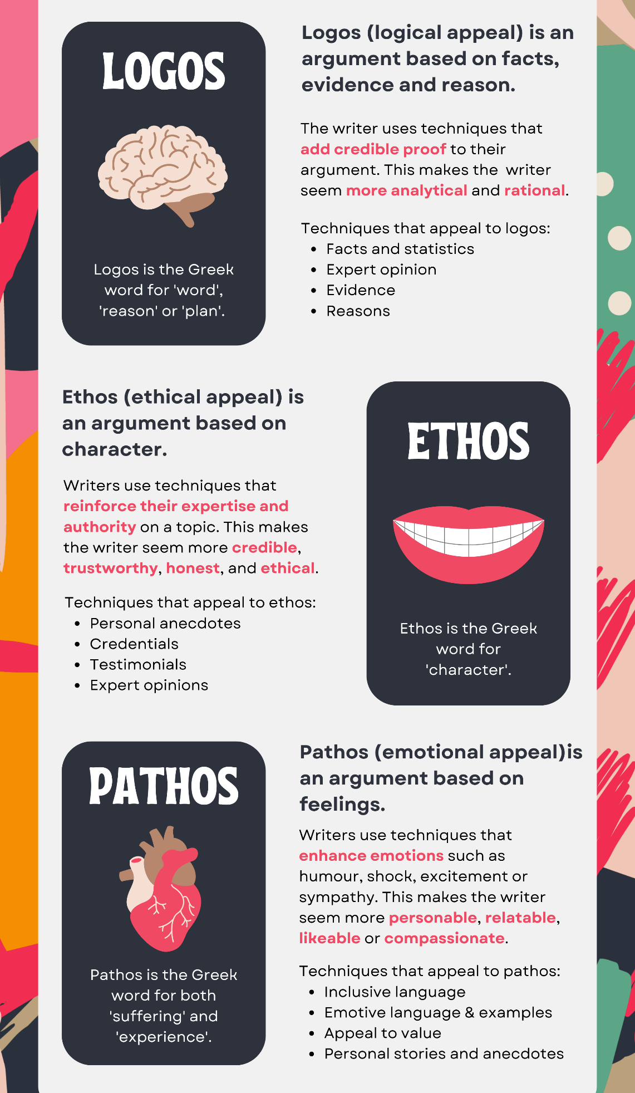

These three modes of persuasion have been widely used in everyday life, from advertisements to political speeches. For example, consider the following excerpt of this marketing copy of a popular tablet for students:

Excerpt A
Your classroom can be anywhere.

Learning untethered. With fast Wi-Fi and cellular capabilities, built-in cameras help you create powerful connections wherever you are. With the smooth, sleek feel of your device in hand: join class, attend a lecture on Zoom Workspace, tackle a group project on FaceTime, or simply stay in touch with colleagues and classmates from all over.
Source: Adapted from Apple. (n.d.).
Can you identify which appeal – logical, ethical, or emotional – is used in different parts of the excerpt?
Details | Appeal | How?
Orange
Blue
Green
Part 2: Linguistic devices for persuasion
Linguistic devices are specific techniques that enhance the persuasiveness of writing by making it more engaging and impactful. By carefully choosing words and crafting sentences, writers can emphasize key points, evoke emotions, and create memorable messages that resonate with their audience.
In Excerpt A, the following linguistic devices are used to create a compelling narrative about the product. Find out which words, phrases, or sentences have used the following devices.
Linguistic devices | Examples
- Hyperbole
- an exaggerated statement or claim used to emphasize a point or create a dramatic effect
- Imagery
- using descriptive language that appeals to senses (e.g., touch, smell, taste, etc.)
- Parallelism
- using similar grammatical structures in a series of phrases or sentences to create rhythm
For business writing, other linguistic devices are also useful to make your writing more effective and engaging for the reader. Examples can be seen in the box below:
- Allusion: brief references to well-known concepts to create a connection
- Simile: compare two different things directly using “like” or “as”
- Anecdote: short, relevant stories to humanize your message and make it more relatable
- Repetition: repeat key phrases to reinforce the message and make it more memorable
- Triad (Rule of Three): present information in groups of three to make the points more compelling and easier to remember
- Personification: give human qualities to non-human entities to make abstract concepts more relatable
- Metaphor: compare two different things directly without using “like” or “as”
- Rhetorical question: a question asked to make a point rather than elicit an answer
Part 3: Use of rhetorical strategies and linguistic devices
In your project group, prepare a mini pitch of 2 minutes about the solution to your business communication problem. Explain why your solution is effective OR feasible OR Innovative. Try to persuade the audience by using 1-2 rhetorical strategies and 1-2 linguistic devices.
Reflection
- How could your ideas and details in “Section 3: Evaluation of Market and Industry Needs” help you brainstorm and write “Section 4: Proposing a Solution”?
- Which rhetorical strategies and linguistic devices did you find most effective for persuasion, and why?

M2L3 Pre-lesson Activity

Watch the following video titled An Introduction to Ethos, Logos and Pathos – and make notes about the key concepts – https://www.youtube.com/watch?v=9L_G82HH9Tg - Post your notes and any questions to the M2L3: Pre-lesson activities Canvas Discussion.
References:
Apple. (n.d.). Your classroom can be anywhere. https://www.apple.com/hk/en/ipad/?afid=p238%7CsDDbqVM0d-dc_mtid_18707vxu38484_pcrid_698882189698_pgrid_15185293037_pntwk_g_pchan__pexid__ptid_kwd-662952649_&cid=aos-hk-kwgo-ipad--slid---product-

